Presidio La Bahia Poster Activity
(Recommended for grades 4-7)
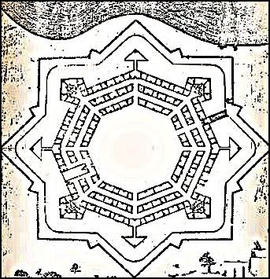

Research diagrams and drawings of Presidio La Bahia. Recreate the diagram using what you learned from your resources on a poster board. Use any drawing medium you want and be sure to color and label the structures and landmarks found in and around the fort.
Materials:
- Blank white poster board (22”x 28”)
- Pencils, markers, paints, map colors (whatever you choose to create your map)

(This activity could also be used for a poster contest in a classroom setting)

