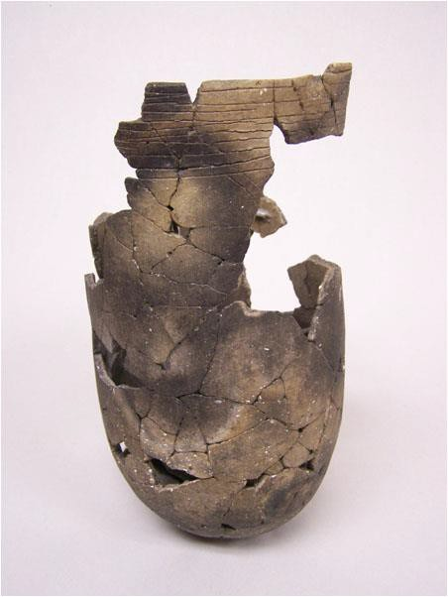

A Pot in a Pinch
(Recommended for any grade level)
The Karankawa lived along the Gulf Coast of Texas. They left behind unique artifacts that archaeologists have begun to uncover. Rockport styled pottery is one of these unique items. Rockport ware had decorative lines around the top. The Karankawa used a material called asphaltum. Asphaltum is a tar-like material that occurs naturally and was regularly used by aboriginal peoples as decoration, caulk, and paint. The Karankawa used pottery and utensils for cooking just as people do today. Unlike many people today, they crafted their own using hand dug fire pits as kilns. They also used sophisticated pottery techniques like the addition of crushed bone to pottery clay. This made the pottery stronger and less likely to shatter. Each piece of pottery was decorated and had unique symbols and markings.
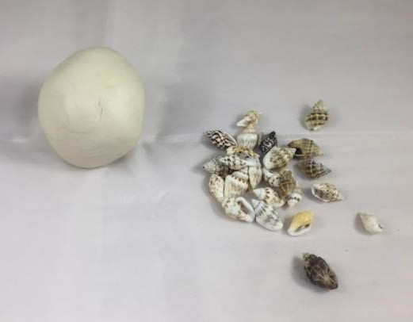
Activity: Making your own Pinch Pot

What you need:
- Air-Dry Clay
- Beads, seashells, and other desired decorating materials
- Toothpicks

Activity:
- Take fistful of air-dry clay and form it into a ball by rolling it between your palms.
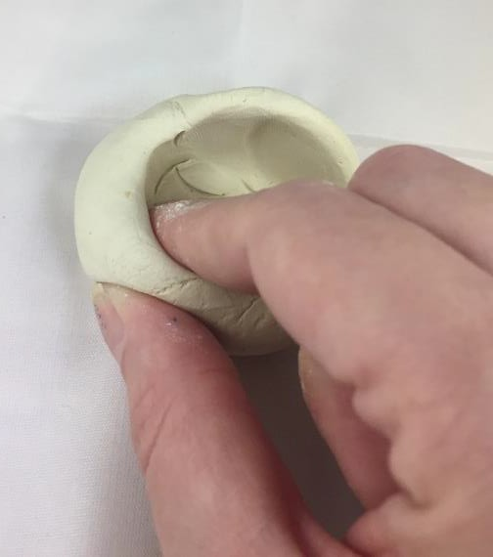
- Take your thumb and press it into the middle of the clay ball in order to make an indentation.
- While keeping your thumb in the indentation, use your other fingers to pinch the clay in a circular direction to hollow out the clay. Try not to make the sides too thin.
- Continue to pinch and mold the clay until you have the pot shape that you like.
- Press your seashells and beads into the sides of the clay until they stick into the clay. Use as much as you like but do not put any on the very top.
- Using your toothpick, trace lines around the rim of your pinch pot. You can trace as many lines around the rim as you like, remember, it’s your pot.
- Let the clay dry for a day.
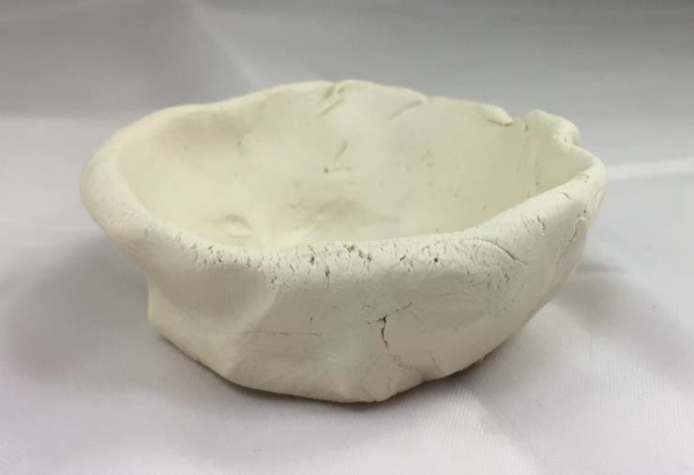
- You may paint the pot if you wish after it has completely dried.
