Archaeology Crossword Puzzle
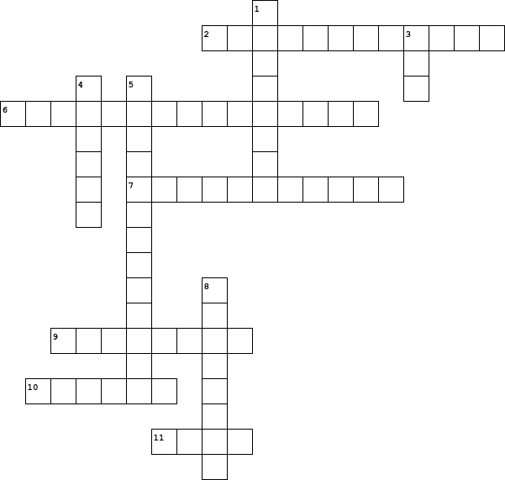

  Across
  2. | The geological study of the layering of soil over time.
  6. | Ancient people who moved around constantly hunting animals and gathering plants.
  7. | The study of human history and prehistory through the digging up of places and analysis of artifacts and human remains.
  9. | An item made by a human being that was preserved, intentionally or unintentionally.
  10. | Stone area in front of a fireplace.
  11. | The place where artifacts are found and recorded before being moved to the lab.
  Down
  1. | To maintain or keep intact.
  3. | All-purpose pointed tool usually made of a long bone splinter used for punching holes in animal hide.
  4. | Layers of archaeological material.
  5. | A person who studies human history and prehistory by digging up sites and artifacts.
  8. | To make a hole by digging up ground.

