Layer-By-Layer (Grades 4 - 7)
Stratigraphy is the process by which layers of sediment are laid down upon each other over time. Archaeologists use stratification to tell how old an artifact is based on its position in the sedimentary layers. The deeper the layer, the older the artifact.

Activity:
You are an archaeologist that has uncovered some artifacts at a dig site. It is extremely important to keep track of where you found each of the artifacts so that you can determine their age. Draw an arrow to connect the artifact to the layer of sediment it is most likely to be found in using your knowledge of stratigraphy.
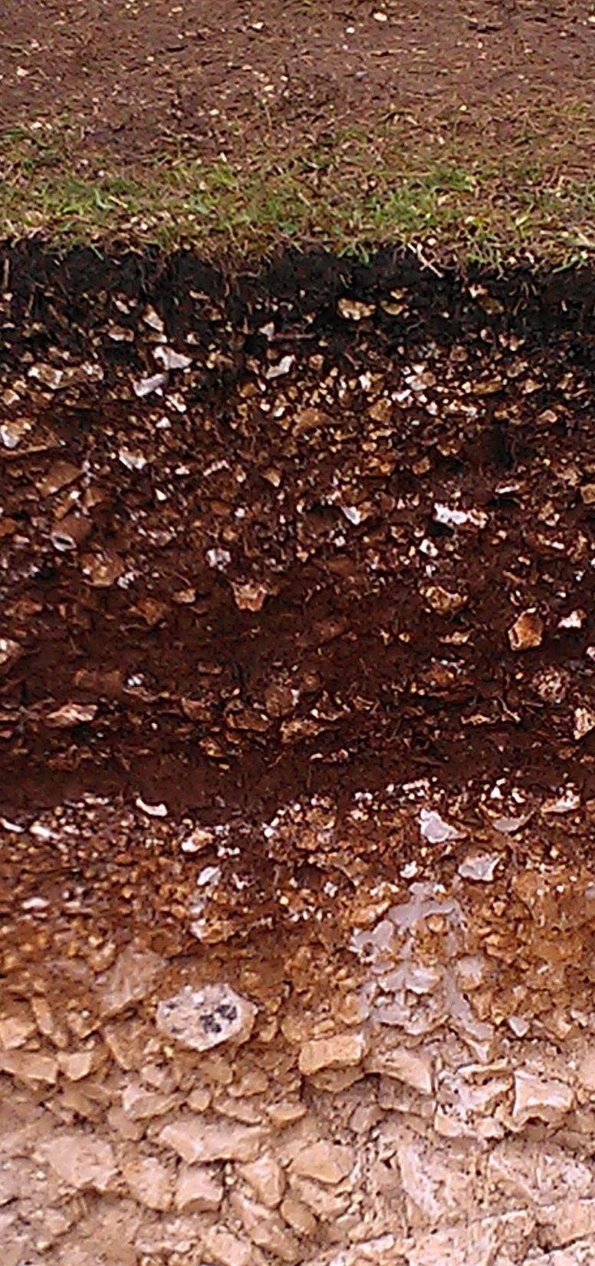  STRATUM A  STRATUM B  STRATUM C  STRATUM D | 