Stratigraphy Activity
(Recommended for grades 1-4)
You have learned that archaeologists use the stratigraphy process to tell how old an artifact is based on the layer and condition of soil in which it is found. Complete the activity below to see just how the layering of soil looks before it is excavated.

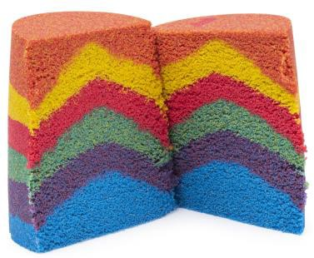
What you need:
- 3-4 different colors of kinetic sand.
- Clear plastic water bottle (peel off label)
- Masking tape
- Marker

Activity:
- Remove the cap from the water bottle and set it aside.
- Pour first color of kinetic sand into the water bottle until it makes about a two-inch layer (Use a ruler if you wish).
- Pour the next color of kinetic sand into the water bottle on top of the first.
- Repeat previous step until all 3-4 layers have been poured into the water bottle.
- Place the cap back on the water bottle.
- Hold the bottle in one hand pat the top of the top of the water bottle with the palm of the other hand. This will make the sand settle and be more solid.
- Take your masking tape and cut out 3-4 three-inch strips. (One strip for each layer)
- Place each strip of masking tape over each layer horizontally on one side of the bottle.
- Using your marker, number each piece of masking tape from 1 to 3 (or 4 if you have more layers) starting from top to bottom.
- On the bottom-most strip of tape, write the word “Oldest” and on the top-most strip, write the word “Youngest.”

